This week in LCMCC Black History August 7, 2022 – August 13, 2022
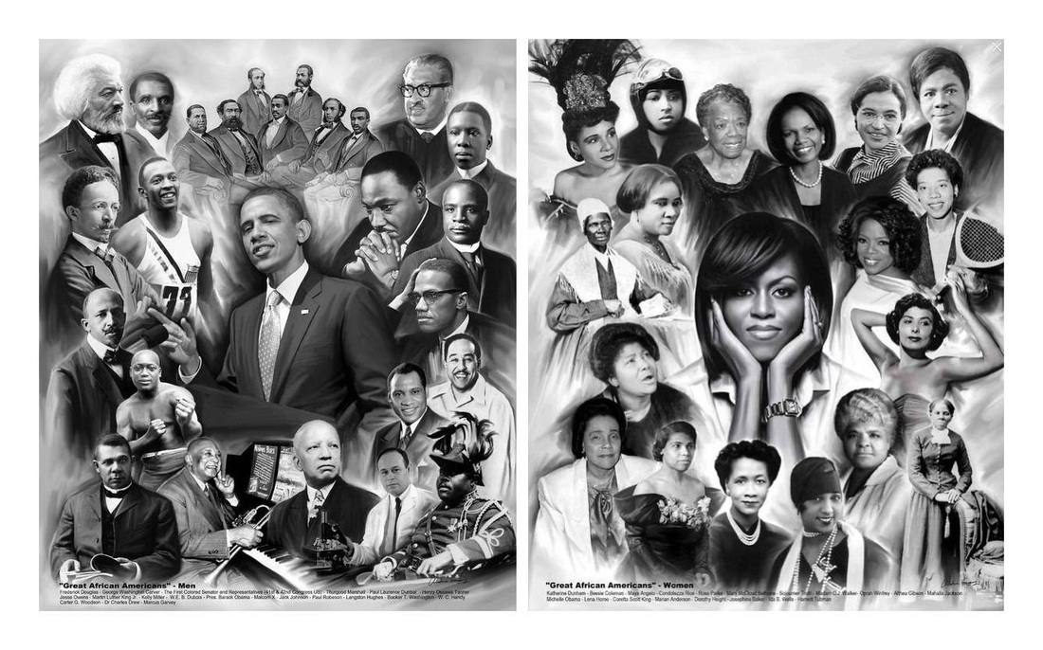
SOTM: 1 John 1:7 (TLB), “But if we are living in the light of God’s presence, just as Christ does, then we have wonderful fellowship and joy with each other, and the blood of Jesus his Son cleanses us from every sin.”

August 7, 1954 - Charles H. Mahoney was confirmed by the Senate and became the first Black to serve as a full delegate
to the United Nations.; 1960 - Black and white students staged kneel-in demonstrations in Atlanta churches.

August 8, 1805 – Officially founded by the Reverend Thomas Paul, The African Baptist Church is the oldest black church in Massachusetts. The first meeting of the congregants took place around 1800. Thomas Paul and Scipio Dalton formed the African Baptist Church after a group of black congregants who had previously attended the predominantly white First and Second Baptist Churches, decided to leave those congregations. Knowing there would be little resistance to their withdrawal, the group received assistance and the blessing of the larger white churches. Dr. Samuel Stillman, pastor of First Baptist Church, agreed to support the new church with the stipulation that they were to “plainly dissuade” white admittance. At the time of its founding the church congregation consisted of 24 members, nine men, and 15 women. With $7,150 raised in funds for the new church, they built an edifice at 46 Joy Street on Beacon Hill which was completed in December 1806. That building is now a national historic landmark called the African Meeting House.
August 9, 1936 - Jesse Owens wins four gold medals in the Berlin Olympics. 1963 - American singer, songwriter and actress and one of the best-selling artists of all time Whitney Elizabeth Houston was born in New Jersey to two-time Grammy Award winner Cissy Houston. The legendary queen of soul, Aretha Franklin, was her godmother. Whitney Houston began singing from an early age by joining in the local choir at the New Hope Baptist Church. By the age of 11 she was singing solo at the choir and also learned to play the piano. In her teens, she performed as a backup singer for Chaka Khan’s song “I’m Every Woman” as well as other performances with Lou Rawls and Jermaine Jackson. She also worked as a model and appeared in several magazines such as Vogue, Glamour, Cosmopolitan and even the cover of Seventeen magazine, one of the first African American women to be featured on a magazine cover.
August 10, 1894 – Congressman George Washington Murray was himself responsible for 12 patents which include: Combined Furrow Opener, Stalk Knocker, Cultivatior and Market, Planter, Cotton Chopper and Fertilizing Distributor, among others.; 2008 - Isaac Hayes died in Memphis, Tennessee due to complications arising from a stroke..
August 11, 1936 - Olympic gold medal in the 800-meter run, went to "Long" John Woodruff.; 1992 – Anthony Phills received U.S. patent #5,136,787 for a ruler template for computer keyboard.
August 12, 1990 - August Wilson's play The Piano Lesson wins the Pulitzer Prize for drama. It is the second Pulitzer Prize for Wilson who also won one for Fences in 1981 and was award the New York Drama Critics Award for Fences, Ma Rainey's Black Bottom, and Joe Turner's Come and Gone.
August 13, 1881 – The first African American nursing school opens at Spelman College in Atlanta, Ga..

